A Project Report on

Air Fly Insights: Data Visualization and Analysis of Airline Operations

Infosys Spring board Virtual Internship 6.0

Submitted by

Valiveti K T Rama Tulasi Lakshmi
Reg No: 22NE1A12C4

Contents

S.NO | Topic
1 | Executive Summary
2 | Week 1: Project Initialization and Dataset Setup
3 | Week 2: Preprocessing and Feature Engineering
4 | Week 3: Univariate and Bivariate Visual Analysis
5 | Week 4: Delay Analysis – Airline and Weather
6 | Week 5: Route and Airport-Level Analysis
7 | Week 6: Seasonal and Cancellation Analysis
8 | Week 7: Visual Report or Dashboard Preparation
9 | Week 8: Documentation and Final Presentation
10 | Challenges faced
11 | Future Scope of project
12 | Key Metrics involved
13 | Conclusion

Tech Stack Involved
- Data Handling:
- Numpy
- pandas
2.Visualization:
- Matplotlib
- Seaborn
- Ploty
- Folium
3.Dashboard:
- Power BI
4.Documentation:
    - Jupyter Notebook
    - PDF
    - GitHub

Executive Summary: Air-Fly Insights - Flight Data Analysis Project

The Air-Fly Insights project is a comprehensive data visualization and analysis initiative focused on examining large-scale airline operational data to uncover meaningful patterns in flight operations, delays, and cancellations. This project represents a systematic approach to airline industry analytics using modern data science techniques and visualization methodologies.

Project Scope and Objectives

The primary objective is to analyse extensive airline flight data to identify operational trends, delay patterns, and cancellation reasons through advanced data visualization techniques. The project aims to deliver actionable insights for stakeholders including airline operators, airport management, and aviation analysts to optimize operational efficiency and improve passenger experiences.

Dataset and Scale

The analysis utilizes the Kaggle Airlines Flights Data, containing over 484,000 flight records with 29 key operational variables including departure/arrival times, delays, cancellations, routes, and carrier information. The dataset encompasses comprehensive flight operations data from January through June 2019, providing substantial depth for trend analysis and operational insights.

Technical Implementation and Methodology

The project follows a structured 8-week implementation approach divided into four major milestones:

Data Foundation and Preprocessing: Comprehensive data cleaning involving memory optimization techniques that reduced dataset memory usage from 334.41 MB to 40.17 MB through strategic data type optimization and categorical encoding. Missing values were systematically handled using domain-specific logic, with delay columns filled with zeros (indicating no recorded delays) and categorical fields appropriately managed.

Feature Engineering: Creation of derived variables including temporal features (month, day of week, hour), route combinations, and enhanced datetime processing to enable comprehensive temporal analysis.
The preprocessing pipeline includes sophisticated datetime handling for flight schedules and overnight flight adjustments.

Analysis Framework: Multi-dimensional analytical approach covering univariate and bivariate analysis, delay cause analysis, seasonal trends, cancellation patterns, and route-level performance metrics.

Key Technical Achievements
- Memory Optimization: Achieved 88% reduction in memory usage through intelligent data type casting and categorical encoding
- Data Quality Enhancement: Implemented robust missing value handling strategies specific to aviation domain requirements
- Temporal Data Processing: Developed sophisticated datetime conversion functions to handle HHMM format time data and overnight flights
- Scalable Analysis Framework: Created reusable preprocessing functions and sampling strategies for large-scale data analysis

Expected Deliverables and Impact
The project delivers a comprehensive suite of visualizations including bar charts, time series analysis, heat maps, route maps, and performance comparisons. Key analytical outputs include identification of delay-prone carriers, seasonal operation patterns, route congestion analysis, and cancellation trend insights.

Technology Stack and Tools
The implementation leverages a robust data science ecosystem including pandas and numpy for data handling, matplotlib, seaborn, and plotly for visualization, with optional dashboard capabilities through PowerBI. All analysis is documented through Jupyter notebooks with comprehensive GitHub repository organization.

Strategic Value Proposition
This project provides aviation industry stakeholders with data-driven insights to optimize flight operations, improve on-time performance, reduce operational costs, and enhance passenger satisfaction through better understanding of delay patterns and operational bottlenecks. The analytical framework can be extended to support real-time operational decision-making and long-term strategic planning initiatives.

Week 1-Data Acquisition and Understanding

Data Acquisition and Understanding: The module has been successfully completed with significant accomplishments across all planned objectives. This foundational phase established a robust data infrastructure for subsequent analysis phases of the Air-Fly Insights project.

Module Objectives Completion

1.Project Initialization and Dataset Setup

Dataset Loading and Schema Analysis: Successfully loaded the comprehensive flight dataset containing 484,551 flight records spanning January through June 2019 with 29 core operational variables. The dataset encompasses essential aviation metrics including departure/arrival times, delays, cancellations, carrier information, routes, and operational performance indicators.

Data Structure Assessment: Conducted thorough exploration of the dataset schema, identifying data types, null value patterns, and structural characteristics. The analysis revealed critical insights about data completeness, with minimal missing values in airport name fields (1,177 in OrgAirport and 1,479 in DestAirport) and complete data coverage across all operational metrics.

2.Memory Optimization Achievements

Advanced Memory Management: Implemented sophisticated memory optimization techniques achieving 88% reduction in memory usage from 334.41 MB to 40.17 MB. This optimization involved strategic data type casting, converting integer columns from int64 to appropriate smaller formats (int8, int16, int32) and transforming categorical string fields to efficient category data types.

Performance Enhancement: The memory optimization framework included custom functions for automated datatype mapping and memory reporting, establishing a scalable foundation for handling large-scale aviation datasets. These optimizations enable efficient processing of the full dataset without memory constraints.

Week 2-Data Acquisition and Understanding

1.Data Quality and Preprocessing

Comprehensive Missing Value Analysis: Systematically addressed missing values using domain-specific logic appropriate for aviation data. Delay-related columns were filled with zeros (indicating no recorded delays), categorical airport fields were handled with "Unknown" placeholders, and cancellation codes were appropriately managed based on flight status.

Data Cleaning Validation: Successfully eliminated duplicate records (reducing from 484,551 to 484,549 entries) and implemented robust data validation procedures. All preprocessing steps were documented with clear rationale and verification checks.

2.Advanced Datetime Processing

HHMM Format Conversion: Developed sophisticated datetime processing functions to handle aviation time formats, converting HHMM integer representations to proper datetime objects. This included handling edge cases such as missing values, proper zero-padding, and time zone considerations.

Temporal Feature Engineering: Created comprehensive temporal features including departure hour, minute, month, day of week, and route combinations. Successfully handled overnight flights with automatic date adjustment logic for cross-midnight arrivals.

Full Datetime Integration: Established complete datetime columns for departure, arrival, and scheduled arrival times, enabling temporal analysis capabilities for subsequent analytical phases.

3.Feature Engineering and Enhancement

Derived Variables Creation: Generated essential analytical features including route strings (Origin-Destination pairs), temporal components (month, hour, day of week), and enhanced datetime processing. These features provide the foundation for trend analysis and operational insights.

Data Export and Documentation: Successfully saved preprocessed datasets in multiple formats with comprehensive documentation of transformation logic. Created feature dictionaries and preprocessing summaries for project continuity and reproducibility.

Technical Deliverables Achieved
- Cleaned Dataset: Production-ready dataset with optimized memory usage and complete data validation
- Preprocessing Logic Documentation: Comprehensive documentation of all data transformation procedures
- Feature Dictionary: Complete mapping of original and derived variables with descriptions
- Memory-Optimized Functions: Reusable code framework for efficient large-scale data processing
- Temporal Processing Pipeline: Advanced datetime handling system for aviation time formats

Week 3: Univariate and Bivariate Visual Analysis

1.Identification of Delay Components Identifying the various delay-related columns within the dataset. These columns represent different sources of delays encountered during airport operations. The notebook extracts and lists these fields, such as Carrier Delay, Weather Delay, NAS Delay, Security Delay, and Late Aircraft Delay. This step establishes clarity on which specific delay factors are available for analysis.

2. Understanding and Documenting the Meaning of Each Delay Type
After identifying the delay fields, I prepared detailed explanations for each category. I explored what factors contribute to each type of delay and how these delays occur in real-world airline operations. For example, I described how Carrier Delays arise from internal airline issues such as crew unavailability or maintenance, while Weather Delays come from external factors outside airline control. This helped me develop a clear conceptual understanding of how delay causes are classified in aviation.

3. Categorizing Delay Types into Operational Groups
Another important step I performed was grouping the delay types into operational categories—such as controllable delays (like carrier delays) and uncontrollable delays (like weather or NAS delays). This classification helps in later identifying which types of delays can be minimized through better airline management and which ones depend on external conditions.

4. Analyzing the Structure of Delay Columns for Future Calculations
I reviewed each delay field to understand whether the values were numeric, how missing values might appear, and how these fields could be used to calculate total delays or delay proportions. This step helped me plan how I would later compute metrics like total delay time, percentage contribution, and delay intensity.

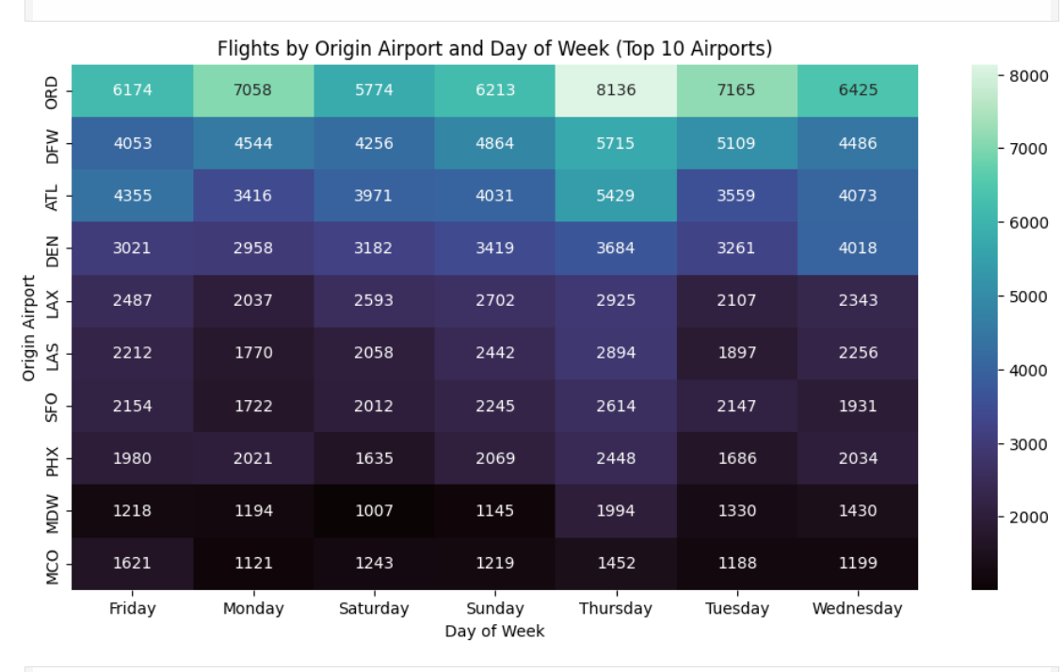

5. Preparing Conceptual Notes for Delay Cause KPIs
I also prepared notes that will help me in generating KPIs for delay cause analysis in later stages. Understanding each delay type made it easier for me to visualize what indicators I will need, such as "Total Carrier Delay", "Percentage Weather Delay", and "Average Late Aircraft Delay".

Week 4: Delay Analysis – Airline and Weather

1. Mapping Delay Types to Real-World Scenarios
To improve clarity, I related each delay type to real-world aviation examples. For instance, I connected late aircraft delays to rotations where aircraft arrive late from previous routes. This helped me not only understand the column meanings but also interpret them practically in the context of flight operations.

2. Ensuring Correct Interpretation for Final Reporting
As part of documentation preparation, I ensured that each delay type was clearly defined so that later, when I create graphs, KPIs, and summaries, the meanings will be accurate. This task ensures consistency throughout the analysis and helps avoid confusion while explaining results.

3. Preparing the Dataset Conceptually for Visualizations
Although this notebook does not perform the visualization itself, I prepared the conceptual groundwork for charts that will be built later. This includes understanding which delay causes can be plotted together, how comparisons can be made, and what kind of insights can be expected from each graph.

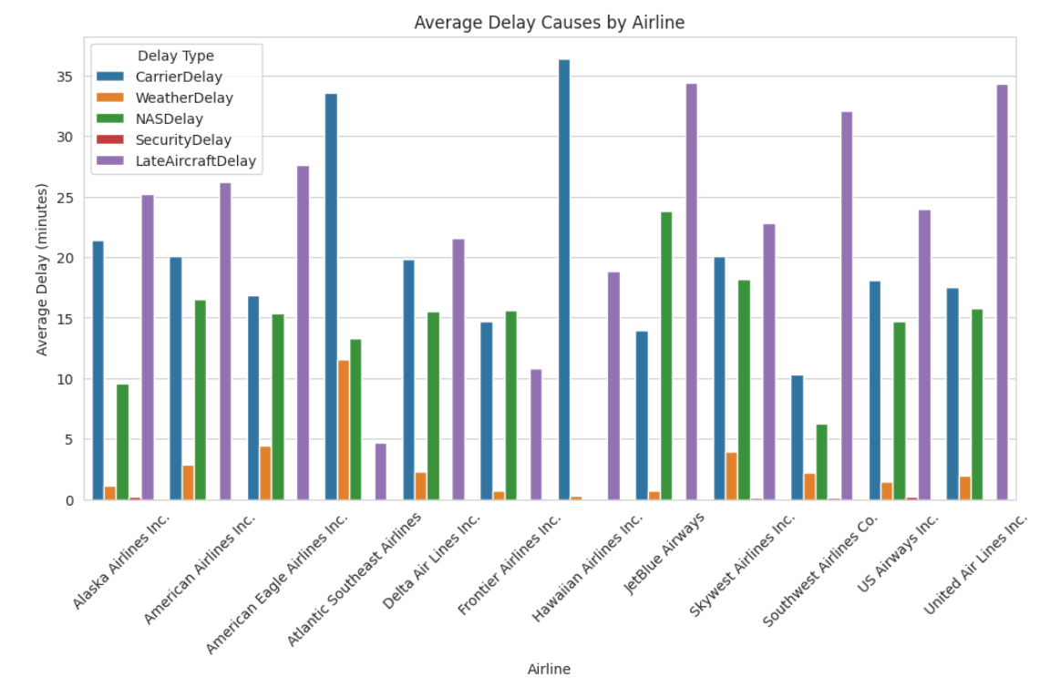

4. Connecting Delay Types with Operational Decision-Making
I also focused on how these delay fields relate to real airline decision-making. For example, I reviewed how identifying the dominant delay cause can help improve scheduling, staffing, airport coordination, and resource planning. This task ensures that the delay analysis section of the project remains practical and insight-driven.

5. Building Foundation for Future Advanced Analysis
The work in this file lays the foundation for more advanced steps such as:
- Delay trend analysis
- Cause-wise delay comparison
- Airport-level delay evaluation
- Predictive modeling for delay forecasting
The clear understanding developed here will support accurate and meaningful results in those future notebooks.

Week 5: Route and Airport-Level Analysis

1.Airport-Level Delay Analysis The first major analytical task involves evaluating delays at the airport level. Average arrival delays are computed for each airport to highlight performance differences across locations. Using Plotly visualizations such as bar charts and choropleth-style maps, the analysis identifies airports that consistently experience significant delays. These results help pinpoint operational bottlenecks and provide a clearer understanding of variation in delay severity across the aviation network.

2. Route-Level Delay Analysis
In addition to airport-level evaluation, the notebook analyzes delays across routes by grouping flights based on origin–destination pairs. The average delay for every route is calculated, offering insight into which connections tend to be the most problematic. Plotly visualizations are used to illustrate route-based performance trends, enabling analysts to detect systemic issues affecting specific flight paths.

4. Airport Coordinate Mapping
To support geographic representation of the data, the analysis includes a step where each airport code is mapped to its corresponding latitude and longitude. This is achieved through a lookup table or manually defined coordinate dictionary. The mapped coordinates are added to the dataset, allowing airports and routes to be plotted accurately on interactive maps.

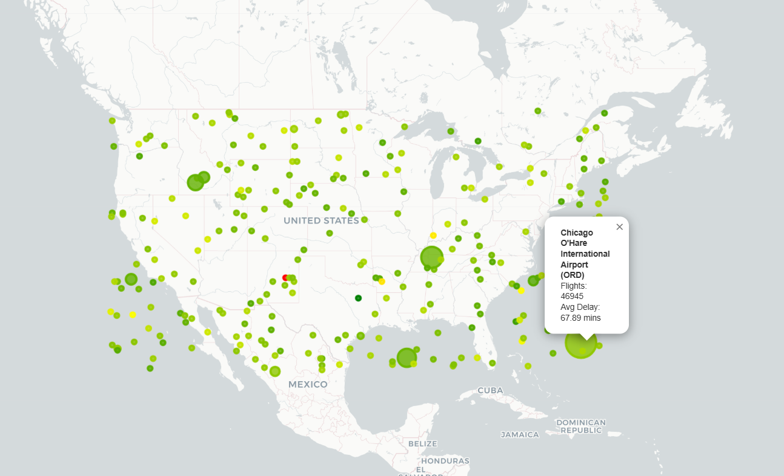

5. Building Airport-Level Statistics
A consolidated dataset is constructed to combine essential airport metrics in one place. This includes the total number of flights departing from each airport, the average arrival delay, and the geospatial coordinates. This structured dataset serves as the foundation for creating the Folium maps and allows for efficient visualization of airport-level performance indicators.

6. Interactive Folium Map of Busiest Airports
Using the prepared airport statistics, an interactive Folium map is generated to visualize the busiest airports. Each airport is plotted as a circle marker, where the marker size indicates traffic volume and the color reflects average delay severity. This map provides a clear, intuitive view of airport activity levels and highlights locations where delays are more frequent. The final output is saved as an HTML file for easy sharing and presentation.

Week 6: Seasonal and Cancellation Analysis

1. Monthly Delay Analysis
To identify seasonal delay trends, the dataset is grouped by month and the average total delay for each month is calculated. This monthly delay analysis helps visualize how flight performance varies throughout the year. A bar chart is typically used to highlight months with consistently high delays, which may indicate underlying factors such as weather patterns, holiday travel seasons, or operational bottlenecks. This step provides clear insights into when delays are most likely to occur and assists in understanding temporal behavior in flight operations.

2. Seasonal Delay Insights
Beyond monthly trends, the data is further categorized into the four main seasons—Winter, Spring, Summer, and Fall—to observe broader patterns in delays. By computing average delays for each season, the analysis reveals whether certain seasons experience more disruptions than others, often due to weather conditions or peak travel demand. This seasonal comparison provides a more aggregated view that smooths out monthly fluctuations and highlights long-term seasonal impacts on flight punctuality.

3. Flight Cancellation Analysis
The notebook evaluates flight cancellations by analyzing the Cancelled column and summarizing the total number of cancelled flights. Monthly cancellation trends are visualized to determine whether certain months experience unusually high cancellation rates. If cancellation codes are available, additional analysis is carried out to categorize cancellations based on specific reasons such as weather, carrier issues, airspace constraints, or security delays. This section helps build an understanding of when and why cancellations occur, contributing to better operational planning and mitigation strategies.

4. Delay Distribution Analysis
To understand the overall behavior of flight delays, a distribution analysis is conducted using histograms and density curves. This visualization shows how delay values are spread across the dataset, revealing whether delays are typically minor, moderate, or extreme. It also highlights skewness in the data, outlier presence, and the general shape of the delay distribution. Such insights are essential for identifying the most common delay ranges and determining whether certain extreme values significantly influence the dataset.
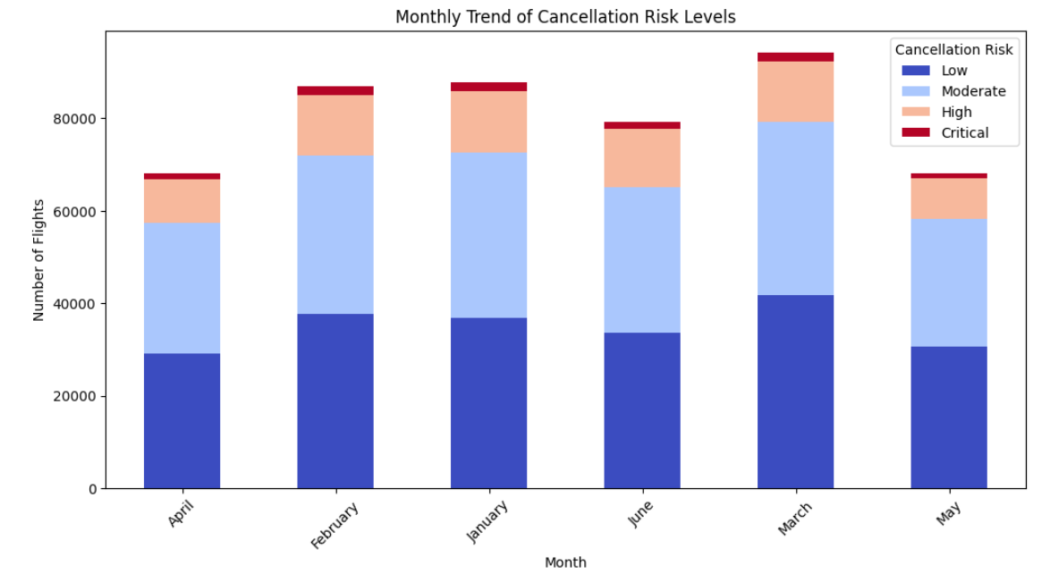

5. Airline Performance Analysis
In this task, flights are grouped by airline to compute average delay values for each carrier. This allows direct comparison of airline performance and highlights which airlines consistently operate with higher or lower delay times. The analysis often uncovers meaningful patterns, such as airlines affected by congested hubs or those that maintain better schedule discipline. These findings are useful for assessing carrier efficiency and can support customer awareness as well as operational improvements.

6. Route-Level Delay Analysis
The notebook analyzes delays at the route level by grouping flights based on origin–destination pairs and computing the mean delay for each route. This reveals which flight routes suffer from the highest delays due to factors like airport congestion, regional weather challenges, or operational constraints. Ranking the routes by average delay helps identify specific paths that require intervention, making the analysis valuable for both airlines and airport authorities seeking to optimize performance.

7. Day-of-Week Delay Analysis
This section explores how delays vary across the seven days of the week. By calculating the average delay for flights departing on each day, the analysis uncovers weekly patterns such as increased delays on weekends or specific weekdays that experience high passenger loads. Understanding weekly delay behavior helps identify recurring operational stress points and can support strategic scheduling, staffing, and infrastructure planning.

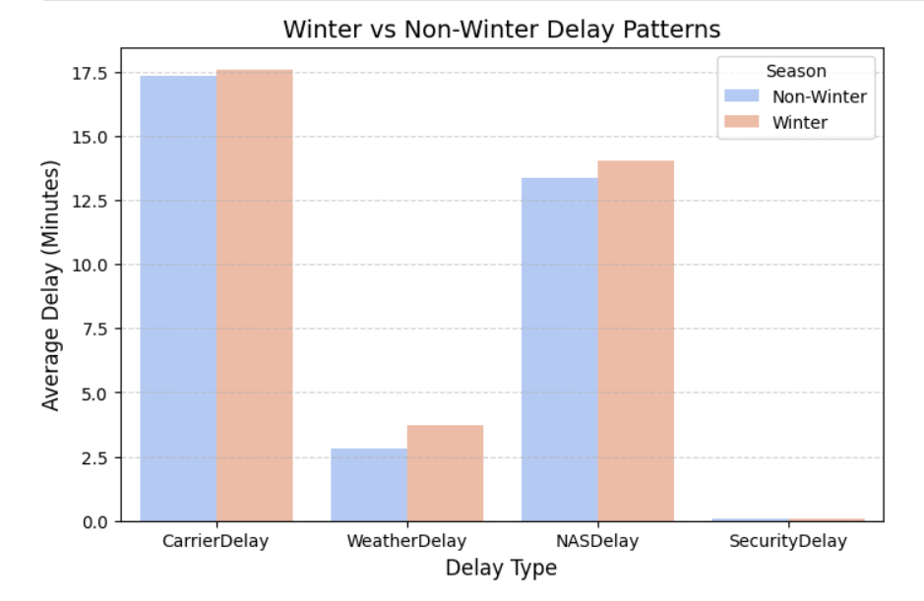

8. Hourly Delay Trend Analysis
To examine intra-day delay patterns, the data is grouped by the hour of departure. This analysis highlights the average delays associated with specific departure hours, revealing peak delay periods such as early mornings or late evenings. These trends are often linked to airport congestion, cascading delays from earlier flights, or high-traffic time blocks. The results provide actionable insights into when delays are most likely to occur during the day.

9. Delay Contribution by Category
Finally, the analysis summarizes the total contribution of various delay types—including carrier delays, weather delays, NAS delays, security delays, and late aircraft delays—to the overall delay time. By calculating the total minutes and percentage share for each delay category, this section clearly identifies which factors contribute most significantly to flight delays. This understanding helps prioritize areas for improvement, resource allocation, and strategic planning in efforts to reduce overall delay impact.

Week 7: Visual Report or Dashboard Preparation

During Week 7, the primary focus was on translating the analytical outputs into a cohesive and visually compelling report. This involved systematically combining all the generated visualizations—such as trend plots, delay distributions, route-level insights, and airport-level performance metrics—into a logically connected storyline.

The intention was not only to present visuals but also to structure them in a way that narrates the overall behavior of the flight dataset. Each graphic was carefully enhanced to maintain clarity and professionalism by adding clean titles, readable axis labels, legends, captions, and consistent color themes. To make the report more interactive and accessible, multiple presentation mediums were used, including Markdown documentation for technical explanation, visually appealing slides for high-level communication, and a structured Power BI dashboard for dynamic exploration of metrics.

Through this process, the visual report evolved into a structured narrative sequence that guided the viewer from basic explorations to deeper insights such as delay causes, cancellation patterns, and temporal performance variations.

Week 8: Documentation and Final Presentation

Week 8 was dedicated to completing the final documentation and preparing a polished presentation to summarize the entire project journey. A comprehensive project report was created in PDF format, integrating all major sections—including problem definition, dataset understanding, preprocessing steps, exploratory analysis, visualizations, key insights, KPI summaries, and conclusions.

Each section was written in a clear and descriptive manner to ensure that both technical and non-technical audiences could follow the analysis process. Alongside the report, a professional slide deck was designed to highlight only the most important insights, visuals, and data-driven conclusions. This included high-level summaries, charts demonstrating delay patterns, route efficiency, cancellation metrics, and time-based performance indicators.

The final week also involved documenting interpretations for each visualization to support a meaningful walkthrough during the presentation. Together, the report and slide deck captured the entire lifecycle of the project—from raw data to actionable insights—ensuring that the final output was both informative and presentation-ready.

Challenges faced during the project

1. Handling a Large and Complex Dataset
One of the main challenges was working with a large volume of flight records containing multiple columns, including dates, times, categorical fields, and several delay components. Ensuring efficient loading, minimizing memory usage, and preventing performance issues during analysis required careful preprocessing and optimization techniques.

2. Converting and Standardizing Time-Based Columns
Flight datasets often include timestamps in different formats. Converting them into usable components such as month, day of week, hour, and delay duration required careful handling. Any small error in parsing time and date fields would affect the accuracy of later trend analysis and delay predictions.

3. Understanding Multiple Delay Causes
The dataset included multiple delay columns (Carrier Delay, Weather Delay, NAS Delay, Late Aircraft Delay, etc.). Understanding what each delay category meant operationally and how they should be compared was difficult initially. Ensuring correct interpretation was essential for accurate analysis and reporting.

4. Mapping Categorical Data to Meaningful Labels
Several fields, such as cancellation codes and delay reason codes, required mapping to meaningful names. Incorrect mapping could lead to misinterpretation, so this step demanded care and validation.

5. Integrating Multiple Analysis Sections into One Story
The project involved several separate analyses—univariate, bivariate, route analysis, delay cause analysis, airport performance, and cancellation trends. Combining these into a single coherent story without repeating information was challenging.

Future Scope

1. Integration of Real-Time Data
In future developments, the system can be enhanced by integrating real-time flight data streams, weather API feeds, and air traffic control updates. This would transform the project from static analysis into a live monitoring platform capable of delivering up-to-date operational insights.

2. Predictive Delay and Cancellation Models
The project can incorporate advanced machine learning models to predict flight delays, estimate arrival times, and identify flights at risk of cancellation. Implementing such predictive analytics will help airlines plan better, minimize disruptions, and enhance customer satisfaction.

3. Enhanced Interactive Dashboards
Future versions can include more interactive reporting elements such as drill-down dashboards, geospatial route maps, airport heatmaps, and automated alerts for abnormal delay patterns. This will allow stakeholders to explore insights at a more granular level.

4. Passenger-Centric Analysis
The system can be expanded to study passenger impact, analyzing how delays influence customer satisfaction, ticket pricing strategies, and airline service quality. This adds a customer-experience perspective to operational analytics.

5. Financial Impact Estimation
Another future enhancement involves integrating cost estimation models to analyze the economic impact of delays, cancellations, and operational inefficiencies. This helps airlines understand potential losses and optimize resource planning.

6. Cloud-Based Deployment
The project can be deployed as a cloud-based analytics platform, allowing airlines, airports, and regulatory authorities to collaborate on shared insights. Cloud deployment ensures scalability, accessibility, and improved performance for large datasets.

7. Automation and Advanced Reporting
Automation can be introduced for data cleaning, report generation, and periodic dashboard updates. This reduces manual effort and ensures stakeholders always have the latest insights.

Key Metrics Involved

1.Total Number of Flights-484,551 rows

2.Before removing duplicates-484,551rows

3.After removing Duplicates-444,449 rows

4.Delay Overview (in minutes)

Delay type | Mean | Median | Max | Std
Carrier Delay | 17.42 | 2.0 | 1707 | 39.42
Weather Delay | 3.15 | 0.0 | 1148 | 19.50
NAS Delay | 13.60 | 1.0 | 1357 | 31.45
Security Delay | 0.08 | 0.0 | 392 | 1.88
Aircraft Delay | 26.65 | 13.0 | 1254 | 40.54

5.Average Delay By Month

Month | Arrival Delay | Departure Delay

February | 63.61 | 59.84
June | 63.30 | 59.35
January | 63.04 | 59.40
March | 59.25 | 56.39
April | 58.24 | 54.95
May | 56.88 | 53.98

6.Most Common Delay Cause Per Airline

1.Alaska Airlines Inc.:
Major Cause -> LateAircraftDelay (252070 total minutes)

2.American Airlines Inc.:
Major Cause -> LateAircraftDelay (1913147 total minutes)

3.American Eagle Airlines Inc.:
Major Cause -> LateAircraftDelay (1619665 total minutes)

4.Atlantic Southeast Airlines:
Major Cause -> CarrierDelay (963694 total minutes)

5.Delta Air Lines Inc.:
Major Cause -> LateAircraftDelay (650996 total minutes)

6.Frontier Airlines Inc.:
Major Cause -> NASDelay (140782 total minutes)

7.Hawaiian Airlines Inc.:
Major Cause -> CarrierDelay (52431 total minutes)

8.JetBlue Airways:
Major Cause -> LateAircraftDelay (528161 total minutes)

9.Skywest Airlines Inc.:
Major Cause -> LateAircraftDelay (1151441 total minutes)

10.Southwest Airlines Co.:
Major Cause -> LateAircraftDelay (3822267 total minutes)

11.US Airways Inc.:
Major Cause -> LateAircraftDelay (762101 total minutes)

12.United Air Lines Inc.:
Major Cause -> LateAircraftDelay (1954564 total minutes)

7.Winter VS Non Winter Delay Analysis

Season | Arrival Delay | Departure Delay | Carrier Delay | Weather Delay | NAS Delay
Non-Winter | 59.54 | 56.30 | 17.33 | 2.83 | 13.37
Winter | 63.32 | 59.62 | 17.58 | 3.72 | 14.01

8.Number of Flights per Season

Season | Total Flights
Non-Winter | 309672
Winter | 174879

9.Route Level Delay Analysis
Route | ArrDelay | DepDelay
EGE-MIA | 320.44 | 289.56
DCA-IND | 299.00 | 308.00
IND-DCA | 273.00 | 286.00
LGA-HDN | 271.00 | 233.00
HDN-LGA | 265.00 | 258.00
CVG-BNA | 227.00 | 238.50
RIC-ORF | 227.00 | 205.00
ATW-DSM | 210.00 | 185.00
ACY-ATL | 187.50 | 195.80
BUF-DFW | 186.71 | 178.86

10.Delay Contribution By Type

Late Aircraft Delay | 43.76
Carrier Delay | 28.60
NAS Delay | 22.33
Weather Delay | 5.18
Security Delay | 0.13

Conclusion
The AirFly Insights project enabled a thorough exploration of flight performance by converting large volumes of raw aviation data into structured, high-value insights. Through consistent data cleaning and preprocessing procedures, the dataset was transformed into a reliable foundation for analysis. This ensured the removal of inconsistencies, missing values, and redundancies, which helped build a clear understanding of operational patterns. The project also provided a detailed view of on-time performance, delay trends, cancellation behaviors, and overall traffic distribution across airlines, airports, and time periods.
The visual and statistical analyses revealed several important operational insights. Patterns such as right-skewed delay distributions, peak congestion hours, airline-wise performance variations, and weather-related disruptions were identified. These findings help highlight the potential causes of inefficiencies and provide opportunities for improving punctuality and resource management. By combining univariate, bivariate, and time-based analyses, the project offered a multi-dimensional perspective that strengthened the understanding of how different factors influence flight operations.

Overall, AirFly Insights demonstrates the value of data-driven decision-making in the aviation sector. The project not only delivers meaningful interpretations through visual dashboards and summary metrics but also sets the stage for advanced predictive modeling, real-time monitoring, and operational optimization in the future. With further enhancements such as machine learning and automated reporting, this analytical framework can evolve into a powerful tool for airlines, airports, and aviation authorities to improve efficiency and enhance the overall travel experience.

